CNS 1410 Object-oriented Programming

Programming Project 12: Ziggy's Web Development and Scuba Shop.

Due Date:
Must be submitted no later than 1:00am on the date specified on the course schedule.
Programs received prior to 1:00am on Sunday will receive 5 bonus points, if the program completely meets the specifications and executes correctly.
This project cannot be turned in late!

Objectives:
The purpose of this final project is to give you experience of working on a larger programming project. This project will require you to use many of the things that you have learned over the course of the semester, and apply them in a cohesive way. In particular, you will be required to:
- Use object oriented design methods
- Develop use cases, CRC cards, and class diagrams
- Use Pointers
- Use Inheritance and Polymorphism
- Use a Graphical User Interface
- Use Operator Overloading
- Manage Memory Correctly
- Use Exceptions
- Use the Standard Template Library

Introduction
Ziggy's Web Development and Scuba Shop is a small start-up venture that needs your help. The company needs a custom developed payroll application. Your goal is to deliver this application in two weeks!

Case Studies
In preparation for this project, a number of case studies have been provided to simulate some of the activities that a development team might engage is as they plan, design, and develop a solution to this programming problem. For students taking the course in the classroom, you will work on these in class in small teams. Distance education students may want to arrange to get together to work on these case studies together.
- Case Study I: Requirements Analysis
- Case Study II: Design
- Case Study III: GUI design
While you may work on the case studies in teams, you are expected to write your own code. You may not copy or use anyone elses code in your final project.

Program Requirements
Your program must:
• Use a Graphical User Interface.
• Read in the employee data from a file. Code the path into your program as "c:\\payroll.txt" (a sample file is provided).
• Read in the sales data from a file. Code the path into your program as "c:\\sales.txt" (a sample file is provided).
• Read in the timecard data from a file. Code the path into your program as "c:\\timecard.txt" (a sample file is provided).
• Show all of the current employees in the company
• Show the employee information (name, address, etc.) for a selected employee.
• Generate a check file. Code the path for this file into your program as "c:\\checks.txt" (a sample file is provided).
For extra credit, you may add the following features to your program:
- Allow the user to edit employee information for a selected employee
- Save all updated employee information back into the payroll file.
- Display employees in alphabetical order

Submitting your final project
Format and document your code in accordance with the course style guidelines. Include a file prologue identifying you as the author. Submit your project using the instructions outlined in the Course Syllabus, Programming Projects section.

Sample GUI
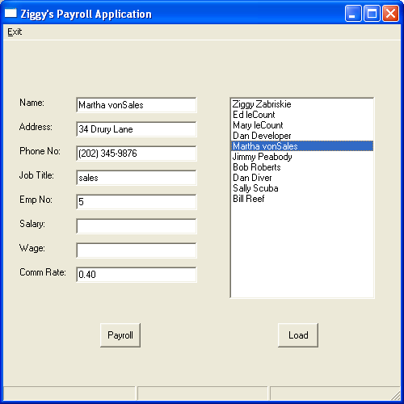

File(s) to Submit:
  - All source code files and an executable file.

Grading
The Grade sheet is here

Hints
Several hints for this program are here

Sample Files
Sample files for the program are:
A sample employee file
A sample sales File
A sample time card file
A sample output file

